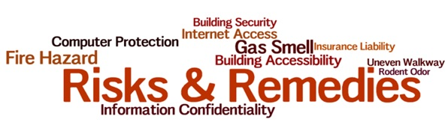

Name: _____________________(optional) Date: ________________

RISK:

_____________________________________________________________________________________________________________________________________________________________________________________________________________

LOCATION OF RISK: ___________________________________________________

CATEGORY OF RISK: ( √ check)

(B) Barrier to Service (L) Legal
(F) Financial (HS) Health and Safety
(HR) Human Resources: deployment, training (O) Other

REMEDY:

_______________________________________________________________________________________________________________________________________________________________________________________________________________________________
Thanks for your feedback.

----------------------------------------------------------------------------------------------------

This section is to be completed by the Risk Management Team
Who’s
Action Date Responsible Confirmation

